

Practices for Secure Software Report

Table of Contents
Document Revision History 3
Client 3
Instructions 3
Developer 4
1. Algorithm Cipher 4
2. Certificate Generation 4
3. Deploy Cipher 4
4. Secure Communications 4
5. Secondary Testing 4
6. Functional Testing 4
7. Summary 4
8. Industry Standard Best Practices 4

Document Revision History

Version | Date | Author | Comments
1.0 | February 20, 2026 | Angel Silva

Client



Instructions

Submit this completed practices for secure software report. Replace the bracketed text with the relevant information. You must document your process for writing secure communications and refactoring code that complies with software security testing protocols.

- Respond to the steps outlined below and include your findings.
- Respond using your own words. You may also choose to include images or supporting materials. If you include them, make certain to insert them in all the relevant locations in the document.
- Refer to the Project Two Guidelines and Rubric for more detailed instructions about each section of the template.

Developer
Angel Silva

Algorithm Cipher
SHA-256 was selected as the cryptographic hash algorithm to implement checksum verification for Artemis Financial’s web application. SHA-256 is part of the SHA-2 (Secure Hash Algorithm 2) family and produces a 256-bit fixed-length hash value from input data of any size.
A cryptographic hash function is used to ensure data integrity. When data is transmitted between client and server, the SHA-256 checksum allows verification that the data has not been altered. If even a single character changes, the resulting hash value changes significantly.
SHA-256 operates without the use of encryption keys because it is a one-way hashing function. Unlike symmetric or asymmetric encryption algorithms, hashing is used for integrity rather than confidentiality. Secure communication confidentiality is provided separately through TLS (Transport Layer Security), which uses asymmetric cryptography for key exchange and symmetric encryption for session data.
Historically, SHA-2 was introduced by NIST as a replacement for weaker algorithms such as SHA-1. SHA-256 remains an industry-standard hashing algorithm and is widely used in financial systems, cybersecurity applications, and modern web security implementations.

Certificate Generation
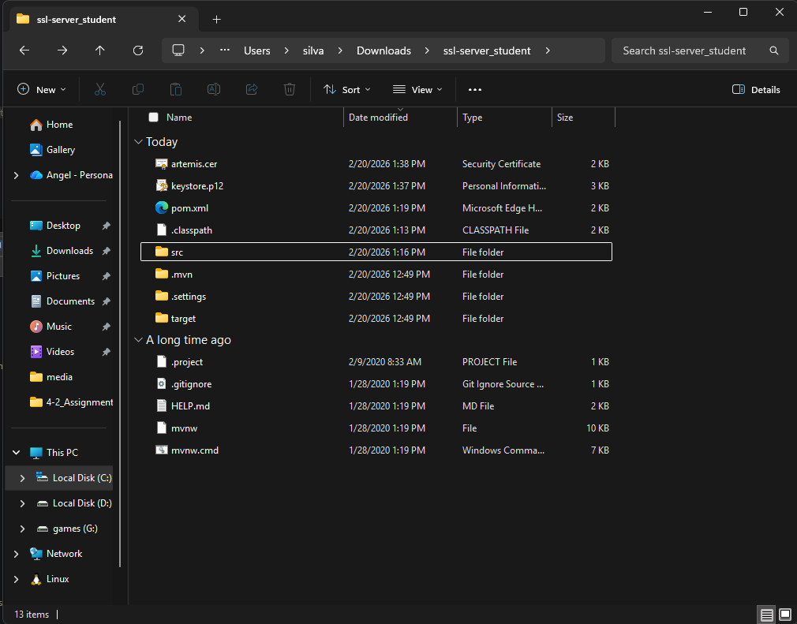

Deploy Cipher
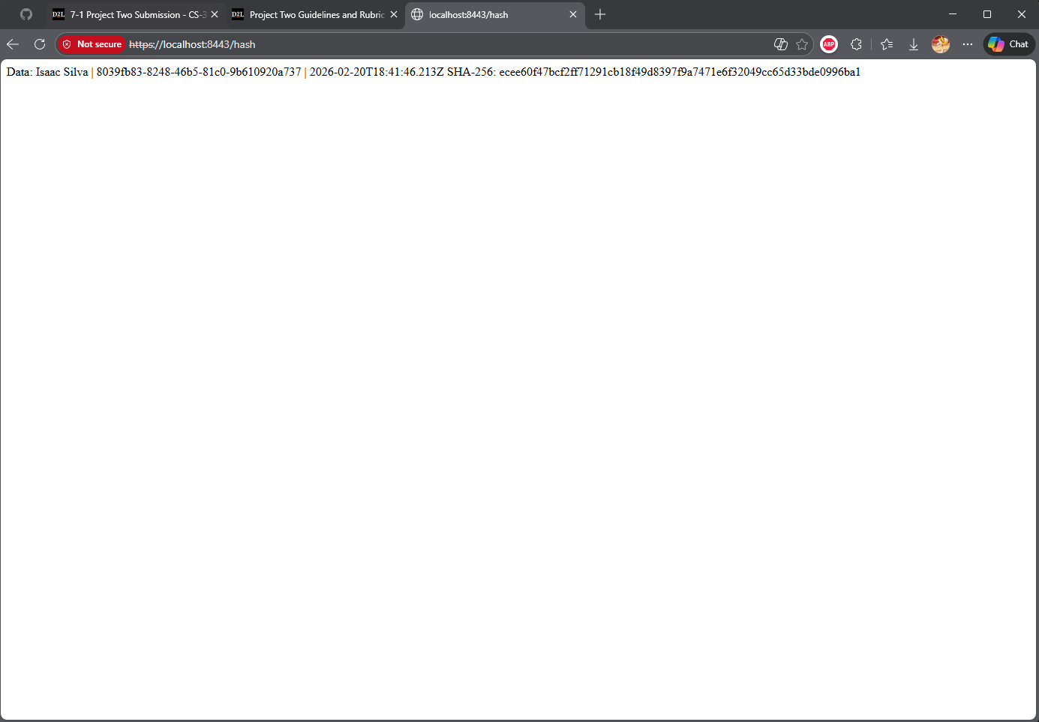

Secure Communications
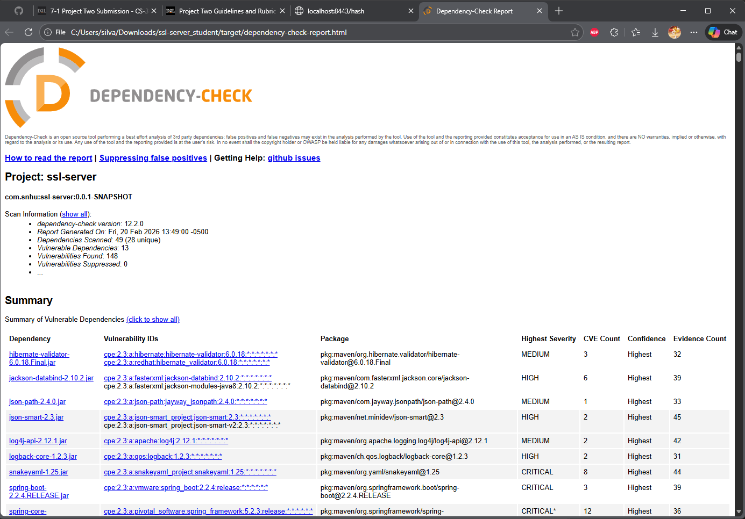

Secondary Testing
After refactoring the application, I executed the OWASP dependency-check Maven plugin to perform static vulnerability analysis. The scan analyzed 49 dependencies and identified several known vulnerabilities in third-party libraries such as Spring Boot 2.2.4, SnakeYAML, and Logback. These vulnerabilities originate from the base framework dependencies and were not introduced by the refactored checksum or SSL configuration code.
No additional vulnerabilities were introduced by the newly implemented SHA-256 hashing functionality or SSL configuration. The dependency-check report confirms that the added secure coding mechanisms comply with software security enhancement requirements.

Functional Testing
Manual functional testing was performed to validate application behavior after refactoring. The application was executed without runtime errors, and the HTTPS endpoint successfully returned a SHA-256 checksum for a uniquely generated data string.
Testing confirmed:
- Secure communication over HTTPS on port 8443
- Successful loading of the self-signed certificate
- Correct SHA-256 checksum generation
- No syntactical or logical errors introduced during refactoring
The application executed without errors in the console, confirming functional correctness.

Summary

The application was refactored to implement secure communication and data integrity verification mechanisms. The refactoring addressed the following areas of the vulnerability assessment process:
- Secure transmission of data via HTTPS using TLS
- Implementation of a cryptographic checksum (SHA-256) to verify data integrity
- Static analysis of dependencies using OWASP dependency-check
- Validation of SSL certificate generation and secure server configuration
Layers of security were added through encryption in transit (TLS), integrity verification via SHA-256 hashing, and static vulnerability scanning to detect potential risks within dependencies. This layered approach strengthens the overall security posture of the application.

Industry Standard Best Practices

Industry-standard best practices were applied throughout the refactoring process. SHA-256 was selected as a secure and widely accepted hashing algorithm for integrity verification. The use of TLS via Spring Boot SSL configuration ensures encrypted communication between client and server.
Rather than implementing custom cryptographic logic, Java's built-in MessageDigest API was used to reduce the risk of improper cryptographic implementation. Additionally, OWASP dependency-check was used to identify known vulnerabilities in third-party libraries, reinforcing secure development lifecycle practices.
Applying these secure coding best practices protects client financial data, enhances trust, reduces liability risk, and aligns with modern cybersecurity standards expected within the financial services industry.

